u|Lg ;f];fO6L klAns :s'n

/=g=kf=–&, ;f}/fxf, lrtjg

bf];|f] q}dfl;s kl/Iff

;doM @ 306f

**laifoM** g]kfnL **k"0ff{ª\sM** %)

**sIffM** o'= s]= hL= **pQL0ff{+sM** !*

**gfd……============================================= /f]n g+================================ ;]S;g======================**

**k|fKtfË**

ko{j]Ifs

k/LIfs

**k|Zg g+= ! rf/ cIf/n] ag]sf zAbx¿ n]Vg'xf];\ . -#_**

**k|Zg g+= @ bL3{ O{sf/ -L_ nfu]sf zAbx¿ n]Vg'xf];\ . -#_**

**k|Zg g+= # zAb agfpg'xf];\ . -%_**

**k|Zg g+= $ nofTds gePsf] zAbdf uf]nf] 3]/f nufpg'xf];\ . -%_**

**afn'jf xn'jf n;'g**

**d';f s'gf 6';f**

**;'v r'/f d'v**

**k'n ;'uf s'n**

**df;' k'/ ;'/**

**k|Zg g+= % j0f{ 5'6\ofP/ n]Vg'xf];\ . -%_**

**k|Zg g+= ^ qmd ldnfP/ n]Vg'xf];\ . -%_**

nfu'a Ö˜

ng;' ˜

nkm" ˜

d5f ˜

s8fk ˜

**k|Zg g+= & afx|v/L n]Vg'xf];\ . -^_**

|  |  |  |  |  |  |
| --- | --- | --- | --- | --- | --- |
|  |  |  |  |  |  |
|  |  |  |  |  |  |

**v**

**k|Zg g+= * P]sf/ nfu]sf zAbx?nfO{ uf]nf] 3]/f nufpg'xf];\ . -^_**

**;'uf hg} d';f**

**uLtf sL/f P]gf**

**w/} tf/f lkª**

**lsnf ;}lgs lstfa**

**cfdf lan k}tnf**

**d}bfg df5f ahf/**

**k|Zg g+= ( lrq x]/]/ gfd n]Vg'xf];\ . -^_**

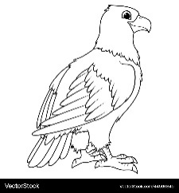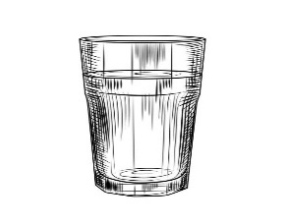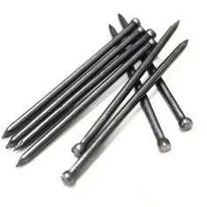

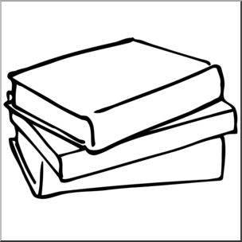

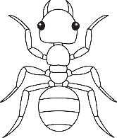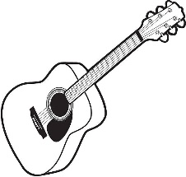

**k|Zg g+= !) zJbx? hf]8]/ jfSo agfpg'xf];\ . -^_**

df5f /fv .

hxfh ;dft .

hd/f r9 .

;dfKt

**The End**

Green Society Public School

Ratnanagar-7, Sauraha, Chitwan

Second Term 2082

Time: 2 hrs.

**Subject: Maths Full Marks: 50**

**Class: UKG Pass Marks: 18**

**Name:________________________Roll No:_______ Sec:_______**

**____________ _________**

**OBT. MARKS**

**INVIGILATOR EXAMINER**

1. **Add(+). (3)**

**4 5 9**

**+ 2 +1 +1**

1. **Write down 5/5 odd and even numbers. (5)**

|  |  |
| --- | --- |
| **Odd** | **Even** |
|  |  |
|  |  |
|  |  |
|  |  |
|  |  |

1. **Write down firm #)–$). (5)**

**#)**

1. **Write the numbers name. (5)**

30=………………….

32=……………..…..

50=………………….

27=…………………

40=…………………

1. **Put sign ‘<’, ‘>’ and ‘=’. (5)**

26◻26

29◻29

17◻11

44◻46

32◻34

**6) cª\snfO{ cIf/df n]Vg'xf];\ . -5_**

**@) Ö !! Ö**

**\* Ö !@ Ö**

**!% Ö**

1. **Write the name of shape. (5)**
2. **Table of 2. (5)**

2x1=

2x2=

2x3=

2x4=

2x5=

2x6=

2x7=

2x8=

2x9=

2x10=

1. **What comes after, before and between. (6)**

|  |  |  |
| --- | --- | --- |
| **Before** | **Between** | **after** |
| **………….22**  **………...34** | **18………….20**  **32……..…34** | **49………….**  **54…….……** |

1. **Complete the pattern. (6)**

|  |  |  |  |  |
| --- | --- | --- | --- | --- |
| Star of David | Meaning, Image, & Facts | Britannica |  | Star of David | Meaning, Image, & Facts | Britannica |  |  |
|  |  |  |  |  |
|  |  |  |  |  |

**The End**

Green Society Public School

Ratnanagar-7, Sauraha, Chitwan

Second Term 2082

Time: 2 hrs.

**Subject: English Full Marks: 50**

**Class: UKG Pass Marks: 18**

**Name:____________________Roll No:__________Sec:_________**

**____________ _________**

**OBT. MARKS**

**INVIGILATOR EXAMINER**

1. **Write down action word. (3)**

1. **Answer the following questions. (3)**
2. **What is your name?**

**My name is ……………………………..………………….…**

1. **How old are you?**

**I am …..………………….… years old.**

1. **Make 3/3 words. (4)**

C

F

B

M

1. **Put ‘a’ or ‘an’ before words. (5)**
2. **………….Orange d. ………… cat**
3. **………….fan e. ………… iron**
4. **………….mango**
5. **Make 'en' words. (5)**

…………………………… ……………………………….

…………………………... ……………………………….

…………………………...

1. **Change singular into plural. (5)**

**a. Pen =**

**b. cat =**

**c. ball =**

**d. potato =**

**e. baby =**

1. Make sentences using ‘These’ and ‘Those’. (5)
2. 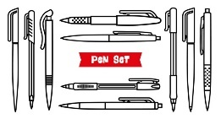……………… are pens.



1. ……………..are flowers.
2. 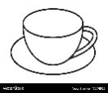 ……….are Butterflies.
3. …………… are cups.
4. **Add ‘ing’. (5)**

**Cook=**

**Play=**

**Go=**

**Eat=**

**Drive=**

1. **Fill in the blanks with He/She/ It. (5)**
2. **…………… is a boy.**
3. **…………… is a girl.**
4. **…………… is a mango.**
5. **………….. is a mat.**
6. **…………. is a mother.**
7. **Make sentences with the help of the given table. (6)**

The end

Green Society Public School

Ratnanagar-7, Sauraha, Chitwan

Second Term 2082

Time: 2 hrs

**Subject: Social Science Full Marks: 50**

**Class: UKG Pass Marks: 18**

**Name:____________________Roll No:__________Sec:_________**

**____________ _________**

**OBT. MARKS**

**INVIGILATOR EXAMINER**

1. Write the name of birds? (3)

…………………. …………………. ……………………….

1. 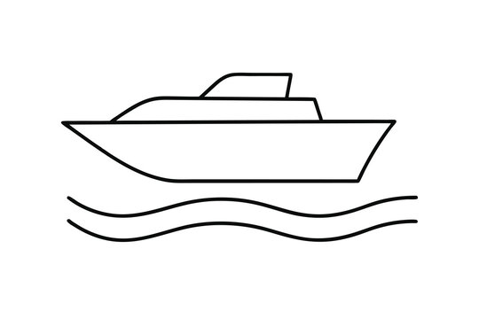Write the name of water transports? (3)

1. Write the name of flowers? (3)



…………………. …………………. ……………………….

1. 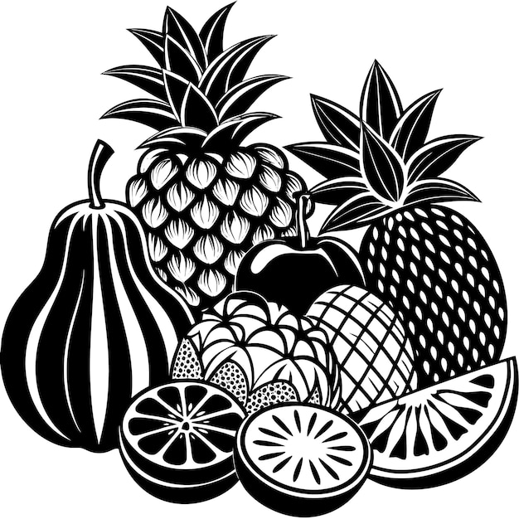Write the name of fruits? (4)
2. 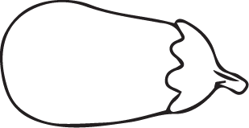Write the name of vegetable? (4)
3. Write the name of water animal? (4)
4. Match the sense organs to their function. (5)

|  |  |  |
| --- | --- | --- |
|  |  | Joyful Boy Listening to Music with Headphones Surrounded by Nature for  Coloring or Tattoo Design 60229516 Vector Art at Vecteezy |
|  |  |  |
|  |  |  |
|  |  |  |
|  |  |  |

1. 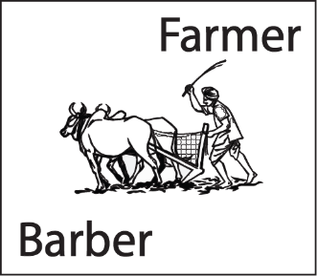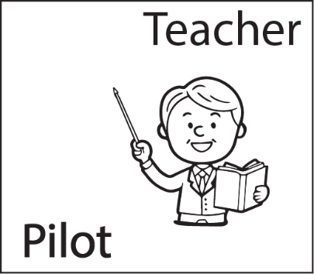Look at the picture and circle the correct word? (5)

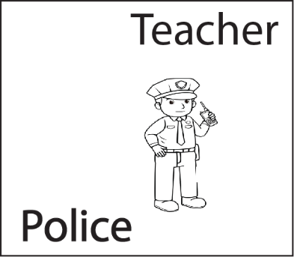

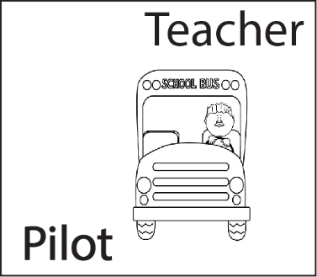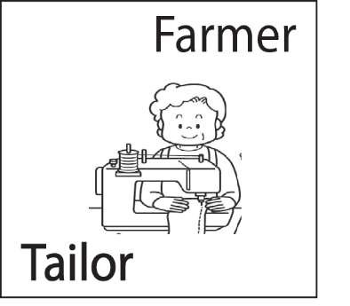

1. Write down 3/3 living things and non living things. (6)

|  |  |
| --- | --- |
| Living things | Non-living things |
|  |  |
|  |  |
|  |  |

1. 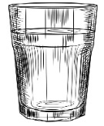Write name of the given picture. (5)

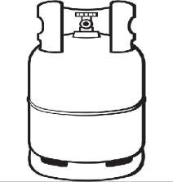

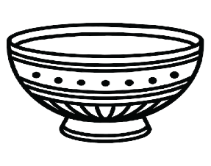

Green Society Public School

Ratnanagar-7, Sauraha, Chitwan

Second Term 2082

Time: 2 hrs

**Subject: Rhymes & Conversation Full Marks: 50**

**Class: UKG Pass Marks: 18**

**Name:____________________Roll No:__________Sec:_________**

**____________ _________**

**OBT. MARKS**

**INVIGILATOR EXAMINER**

Answer the following questions:

1. What is your name?
2. In which class do you read?
3. What is your father's name?
4. What is your mother's name?
5. What is your school name?
6. What is your class teacher's name?
7. what is your country name?
8. What is your school principal's name?
9. What is your School vice principal's name?

!)= tkfO{ slt jif{sf] x'g'eof] <

!!= g]kfnsf] /fli6«o hgfa/sf] gfd s]xf] <

!@= g]kfnsf] /fli6«o km'nsf] gfd s] xf] <

!#= g]kfnsf] /fli6«o /ªsf] gfd s] xf] <

!$= g]kfnsf] /fli6«o xltof/sf] gfd s] xf] <

15. Rhumes

16. Dance

!&= tn lbPsf lrqx¿sf] gfd eGg;xf];\ .

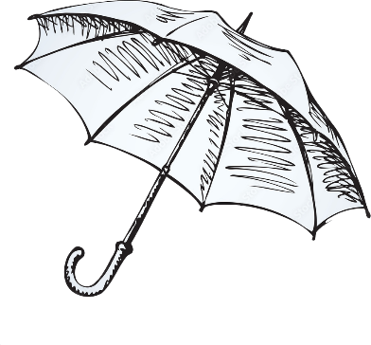

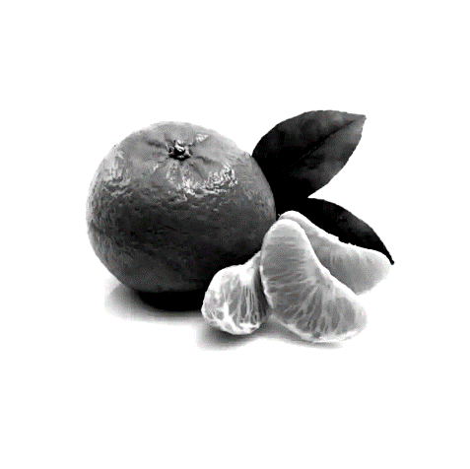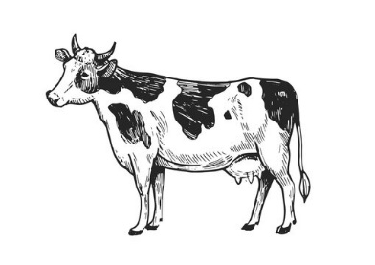

Green Society Public School

Ratnanagar-7, Sauraha, Chitwan

second Term 2082

Time: 2 hrs

**Subject: Project and activity Full Marks: 50**

**Class: UKG Pass Marks: 18**

**Name:____________________Roll No:__________Sec:_________**

**____________ _________**

**OBT. MARKS**

**INVIGILATOR EXAMINER**

1. Colour it. 10

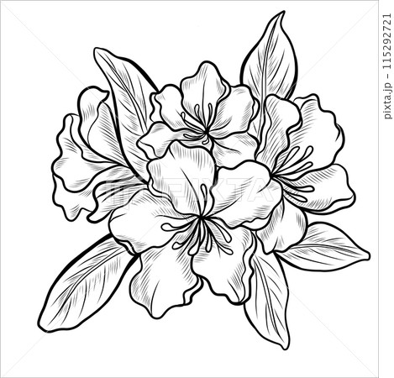

1. 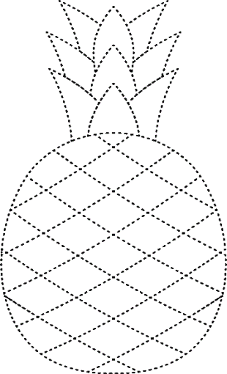Join the dotted line and colour it. 10
2. Draw a picture of butterfly and colour it. 10
3. 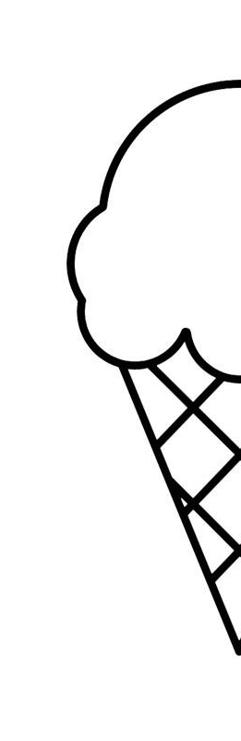Complete the half picture and colour it. 20 